**Virologica Sinica**

**Supplementary Material**

**Baicalein suppresses Coxsackievirus B3 replication by inhibiting caspase-1 and viral protease 2A**

Yanyan Dong a, Enze shao a, Siwei Li a, Ruiqi Wang a, Dan Wang a, Lixin Wang a, Hong Yang a, Yingxia He a, Tian Luan a, Yang Chen b, Yao Wang a, Lexun Lin a, Yan Wang b, Zhaohua Zhong b*, Wenran Zhao a*

a Department of Cell Biology, Harbin Medical University, Harbin 150081, China

b Department of Microbiology, Harbin Medical University, Harbin 150081, China

*Corresponding authors:

Email addresses:

zhaowr@hrbmu.edu.cn (W. Zhao); zhongzh@hrbmu.edu.cn (Z. Zhong)

ORCID:

0000-0003-2495-5138 (W. Zhao); 0000-0002-0778-5053 (Z. Zhong)

H:\6648-\6648 R3\6648 to prod\6648 FigS2.tif

**Figure S1.** Baicalein does not block the entry of CVB3 into the cells. HeLa cells were cultured to 70% confluency. The culture medium was removed and cells were covered with virus diluted with DMEM (MOI = 100) supplemented with baicalein at 50 mol/L. Cells were incubated at 37 °C for 2 h to allow virus attachment and virus entry into the cells. Cells were then washed with PBS to remove attached viruses. Cells were collected and viral RNA was determined with RT-qPCR. Experiments were repeated three times. ns: non-significant. BAI: baicalein.

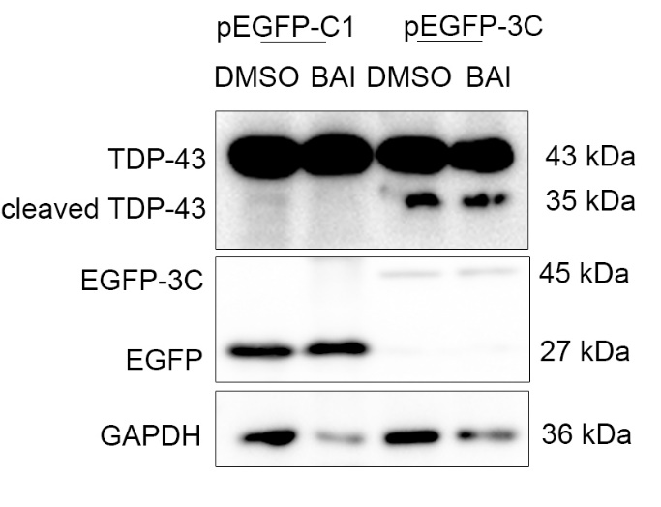

**Figure S2.** Baicalein does not inhibit the activity of 3Cpro of CVB3. The cleavage of TDP-43 was determined to represent the activity of 3Cpro of CVB3. HeLa cells were transfected with pEGFP-3C for 24 h. Control cells were transfected with pEGFP-C1. Cell lysate was collected and subjected to Western blotting.

**H:\6648-\6648 R3\6648 to prod\6648 FigS1.tif**

**Figure S3.** The sequence homology of 2Apro between CVA16 and CVB3. The amino acid sequences of 2Apro between CVB16 and CVB3 are aligned. Amino acids with similar features are highlighted in blue. Amino acids with distinct features are highlighted in red. 2Apro sequence homology between CVA16 and CVB3 is 86%.

**Table S1. Primer sequences for RT-qPCR**

|  |  |
| --- | --- |
| Target gene | Sequence (5’🡪3’) |
| CVB3-Forward primer | GCACACACCCTCAAACCAGA |
| CVB3-Reverse primer | ATGAAACACGGACACCCAAAG |
| CVA16-Forward primer | ATCCAGTAAGGATCCCAGACT |
| CVA16-Reverse primer | GATTTGCATAGTGGAGAGCAG |
| GAPDH-Forward primer (Homo) | TGACCACAGTCCATGCCATCACT |
| GAPDH-Reverse primer (Homo) | ACGCCTGCTTCACCACCTTCT |
| GAPDH-Forward primer (Mouse) | GAGAGTGTTTCCTCGTCCCG |
| GAPDH-Reverse primer (Mouse) | ACTGTGCCGTTGAATTTGCC |